Save Them

By Akshiv Nagta:

Game:

You have to solve the puzzle in order to save the animal. Animal photos are divided into 4 parts. Player has to rearrange them in the right order.

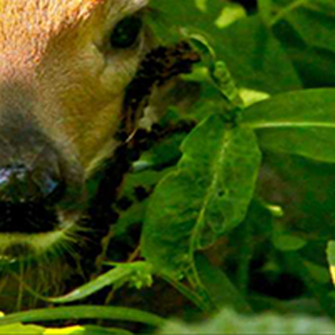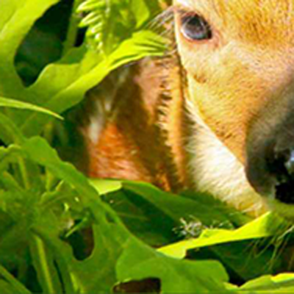

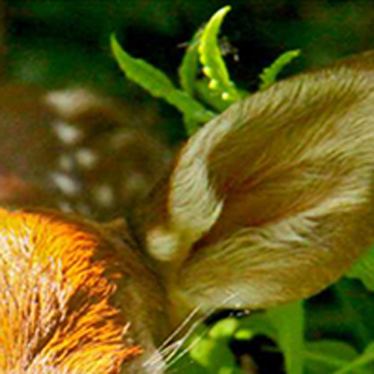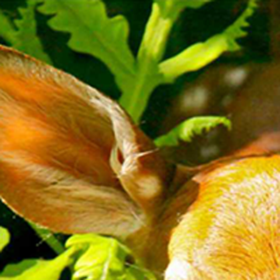





Controls:

Left Click to select any of the four parts of the photo. Type 1,2,3 or 4 to place the photo is the desired location.

“1” is for Top Left “2” is for Top Right

“3” is for Bottom Left “4” is for Bottom Right